S.4 COURSE OUTLINE FOR S.4.
A) STUDIO TECHNOLOGY
- Puppets / Marionettes
- Macrome
- Weaving
- Basketry
ATTEMPT ALL QUESTIONS BELOW;
- Name and explain the principles of two-dimensional art / design.
- a) What is fabric decoration?
b) State and explain the methods of decorating fabrics.
c) Describe the process of decorating a fabric using applique.
- a) Outline the functions of puppets.
b) How is a marionette different from a puppet.
- a) Differentiate between materials and tools.
b) State the factors to be considered before selecting materials for doing an art work.

B) GRAPHICS
1. Poster
2. Badges
3. Trade marks
4. Logo
5. Book Cover
6. Book jacket
7. Calligraphy
C) IMAGINATIVE COMPOSITION
ATTEMPT ALL THE QUESTIONS.
1. An old woman guides her blind husband through a bad section of the road.
2. Law enforcement officers are dispersing a mob of violent demonstrators.
3. Young children play with their grandparent.
4. A drunkard being mocked by villagers.
ATTEMPT MORE TOPICS FROM IMAGINATIVE COMPOSITION.
1. Scared.
2. Celebrations
3. Riding a bicycle in a busy trading center.
NB. Remember to emphasize action, drama, message proportions, composition, colour balance and show principles of art/ design while doing your work.

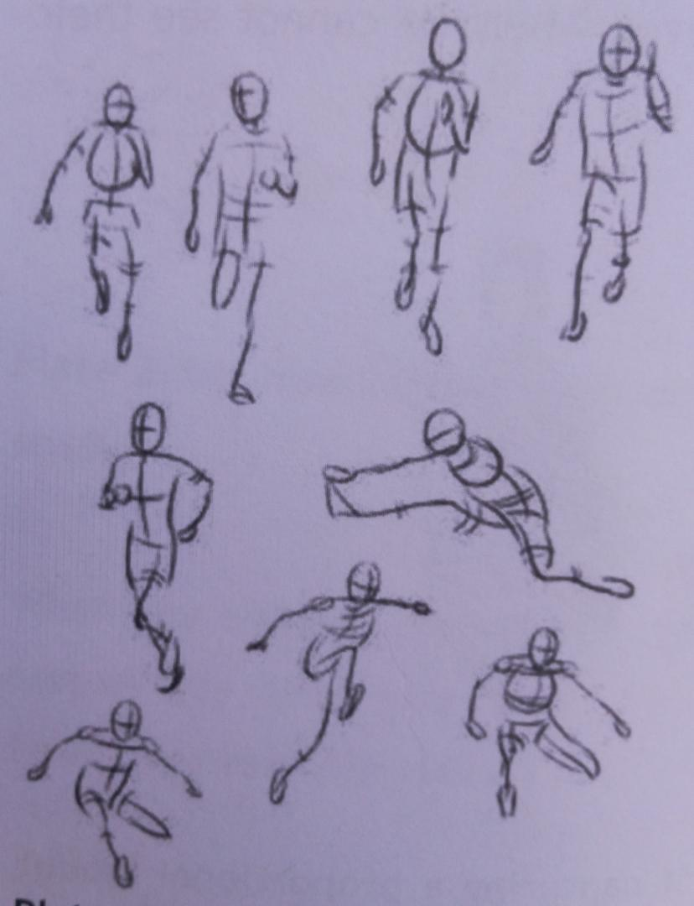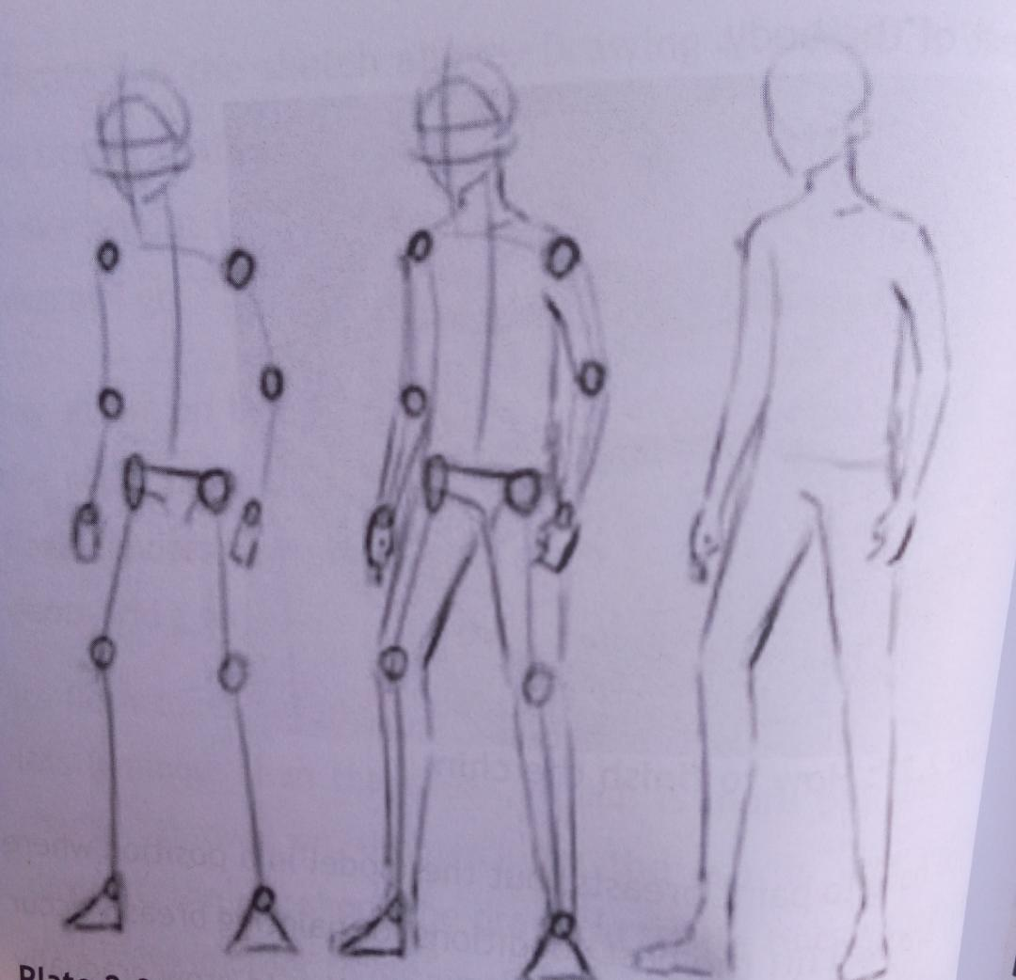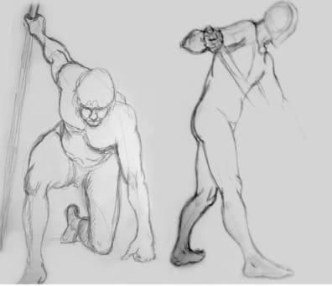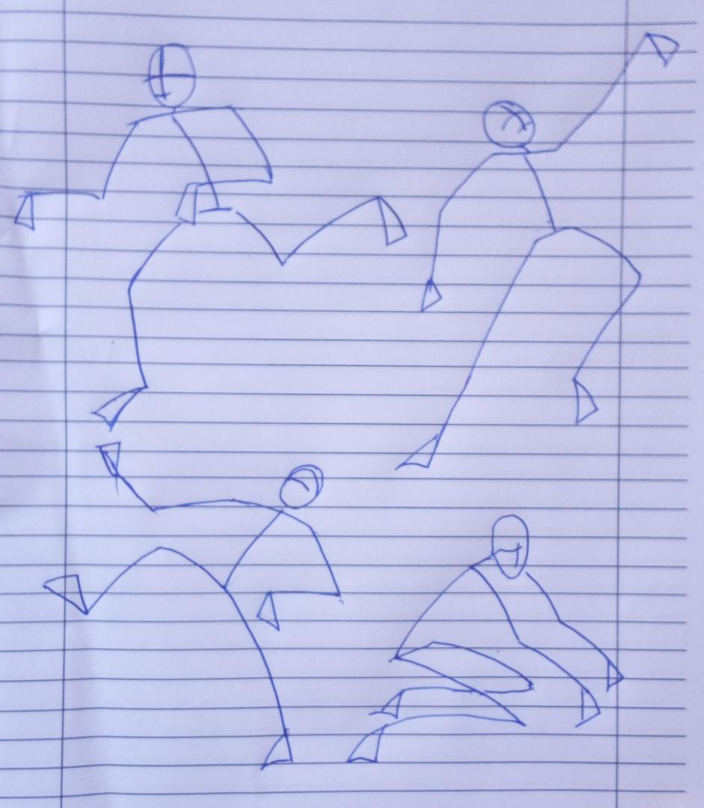

D) STILL LIFE DRAWING
- On a low platform set three cylindrical objects of different sizes with two angular shapes.
- Arrangement of clothes draping from a woven basket.
- A flask with two mugs, a sugar bowl and a small cluster of sweet bananas set on a rectangular tray.
- Study of a fresh twig with thorns.
- Study of an insert a wasp or a cockroach.
- On a wooden chair pile three huge text books. On the right side lean a rolled woven mat.
- Arrange different types of fruits and vegetables such as a pineapple, oranges, mangoes, carrots, egg plants, tomatoes, green pepper in medium size basket.

E) LANDSCAPE DRAWING
- Select a view showing a house, a hedge, trees, a path leading to the gate and a nice compound.
- Draw a Landscape showing a church in your area include the trees, flower gardens and the paths.
- Select a landscape showing a block of classrooms, short hedges, paths, trees, shrubs and a compound.

